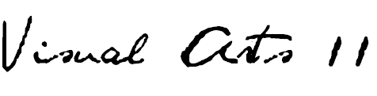
HALIFAX WEST HIGH SCHOOL / R. L. Perry / 2016-2017
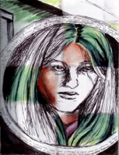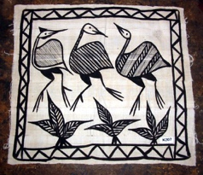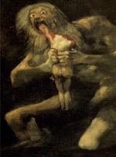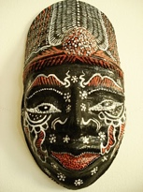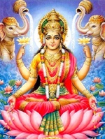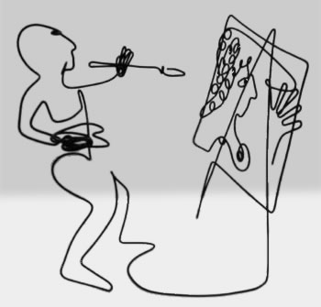
Self-Portraits Cultural Traditions Stylistic Poster Mask-Making Mythological Icons Wire Sculpture
DESCRIPTION
- Art 11 is a continuation of the skills, ideas and interests expressed in Art 10. Students enrolling in the Art 11 course should have a keen interest in the visual arts as well as possess some basic ability in drawing and design based on previous art experiences.
- The core components of this course will include drawing and design, painting. mask-making and sculptural explorations.
- Students will be encouraged to build on their understanding of the sketchbook with journaling, showcasing experimentations, research, reflection, and simple-to-complex observational studies of various subject and media.
- This course, an extension of materials covered in Art 10, will focus on students broadening their experiences through various media, methods, techniques and the introduction of many topics and genres.
- Art 11 students will be expected to enrich their experiences through art historical contexts. Specific focus will be on culturally diverse artists and geographies.
- Students will be required to be actively engaged in visual critique throughout projects as well as being required to produce some research work on a selected contemporary artist.
- Assembling a base of work in a student art portfolio is expected as a valuable assessment tool and should be accumulative through grades 11 and 12.
GENERAL OUTCOMES
General curriculum outcomes designed by the NS Department of Education for this course are as follows…
CREATING, MAKING AND PRESENTING
- Students will be expected to explore, challenge, develop, and express ideas using the skills, language, techniques and processes of the arts.
- Students will be expected to create and/or present expressive (art) products for a range of audiences/purposes.

UNDERSTANDING AND CONNECTING CONTEXTS OF TIME, PLACE AND COMMUNITY
- Students will be expected to demonstrate critical awareness of and value for the role of the arts in creating and reflecting culture.
- Students will be expected to respect the contributions to the arts of individuals and cultural groups in local and global contexts, and value the arts as a record of human experiences and expression.
- Students will be expected to examine the relationship among the arts, societies and environments.

PERCEIVING AND RESPONDING
- Students will be expected to apply critical thinking and problem-solving strategies to reflect on and respond to their own and others’ expressive works.
- Students will be expected to understand the role of technologies in creating and responding to expressive works.
- Students will be expected to analyse the relationship between artistic intent and the expressive work.

UNIT OUTCOMES
- Students will actively review and enhance drawing skills with particular focus on linear silhouette, pattern, facial portraiture as well as value studies.
- Students will actively review and update design skills focusing on various culturally distinguishable means of mark-making and interpreting those into their own personal framework in several different varieties of media.
- Students will demonstrate knowledge of various art styles throughout different cultures and will become familiar with several historically significant as well as contemporary artists.
- Students will be able to describe the cultural significance of the mask as an art object, creating their own mask based on historical and cultural influences.
- Students will demonstrate how to create a visual narrative through art and be able to name working artists that have worked in the same way.
- Students will demonstrate how to conceptually form an idea into both a realistic and an abstracted three-dimensional format. This will include a foray into the world of satire.
- Students will acquire, develop and use a vocabulary of art terms, techniques and styles as well as demonstrate knowledge of artists and art criticism, both verbally and in written form.
- Students will research a contemporary artist and present findings both visually and orally.
ASSESSMENT/EVALUATION
VISUAL ARTS 11 final grades will be an accumulation of formative and summative assessment practices. Various forms of evaluation including observation, small assignments, techniques lessons, major projects, sketchbook assignments, portfolio assessment, tests, self and peer evaluation. Students will complete a final process examination at the end of semester.

The VISUAL ARTS grade will be based on the following breakdown…
- CREATING/MAKING- Major Projects 45%
- UNDERSTANDING/CONNECTING- Sketchbook/Exploratory/Techniques/Context 20%
- PERCEPTION/RESPONSE- Observation/Reflection/Tests/Critique/Self & Peer Evaluation 15%
- PROCESS EXAM-20%
The semester is valued at 80% with a final process exam being the remaining 20% in the FINAL GRADE calculation.
MATERIALS REQUIRED
- SKETCHBOOK 8.5 x 11” or 9 x 12” preferably bound not coiled 80-100 pages min.
- SKETCHING PENCILS at least three such as 2B, 4B, 6B
- WHITE ERASER
- BLACK FELT-TIP MARKER (ultra-fine ‘sharpie’ or ‘le pen’)
- COLOURED PENCILS
- GLUE STICK (large)
- BRISTOL BOARD (for your first assignment- portfolio construction)

OPTIONAL… You may choose to have access to watercolour media (small paintbox or watercolour pencils) for colour work in your sketchbook as well as a small detail brush (number 0 or 00) as well as a medium round (number 6 or 8)
Notes/ handouts may be stored in a binder BUT can be glued/ attached directly in your sketchbook.
*I will be contacting De Serres art store to see about providing all materials in a super–value kit.
CONTACT THE TEACHER
Rosemarie Perry (Ms. Perry) at 457-8900 ext. 5602327
e-mail rperry@hrsb.ca or website www.artwithperry.com

