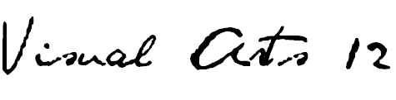
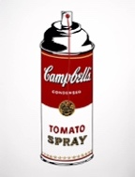
ISLAND VIEW HIGH SCHOOL / Room 117/ R. L. Perry
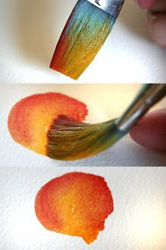
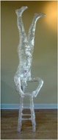
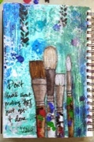
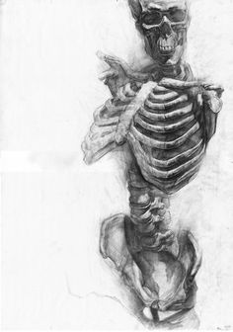
Anatomy Journaling Design Styles Painting Tech. Social Art Sculpture
RATIONALE
Visual Arts 12 builds on previous learning by providing students with experience in a unique and authentic context, that being a “studio” setting. Just as a professional artist develops a space within which they are free to create, the Visual Arts 12 classroom attempts to model a working studio. Students are provided a range of opportunities through extensive projects that allow them to develop and respond to their personal needs and aspirations. Opportunities to explore a variety of materials, technologies and processes and then specialize in areas of particular interest allow them to explore career paths and access community resources.
DESCRIPTION
The main components of Visual Arts 12 are working with drawing skills, design skills, painting skills, sculptural exploration and mixed media. Art history, art philosophy and art criticism will be an integral part of this course. A major project based on art history is to be expected. Students will be expected to incorporate technology into their various uses of media, and will be encouraged to actively participate in coming up with their own images, references and subjects to work with.
Art 12 students will be expected to complete a final project from their own particular area of interest, and take that interest into an in-depth study.
This course is of benefit to students would wish to assemble a portfolio in preparation for entrance into art schools and university art programs.
GENERAL OUTCOMES
General curriculum outcomes designed by the NS Department of Education for this course are as follows…

CREATING, MAKING AND PRESENTING
- Students will be expected to explore, challenge, develop, and express ideas using the skills, language, techniques and processes of the arts.
- Students will be expected to create and/or present expressive (art) products for a range of audiences/purposes.

UNDERSTANDING AND CONNECTING CONTEXTS OF TIME, PLACE AND COMMUNITY
- Students will be expected to demonstrate critical awareness of and value for the role of the arts in creating and reflecting culture.
- Students will be expected to respect the contributions to the arts of individuals and cultural groups in local and global contexts, and value the arts as a record of human experiences and expression.
- Students will be expected to examine the relationship among the arts, societies and environments.

PERCEIVING AND RESPONDING
- Students will be expected to apply critical thinking and problem-solving strategies to reflect on and respond to their own and others’ expressive works.
- Students will be expected to understand the role of technologies in creating and responding to expressive works.
- Students will be expected to analyse the relationship between artistic intent and the expressive work.

UNIT OUTCOMES
- Students will actively review and update drawing skills focusing on human form, demonstrating knowledge of anatomy, proportion, working on facial integrity and expression, all the while developing means of mark making that are unique and varied.
- Students will actively review and update design skills focusing on various stylistic periods, making some of them over into their own personal framework, using various scale and media.
- Students will demonstrate knowledge of the various styles of art, movements and types of artists out there by engaging on a journey that will take them into at least four in depth for a major project and presentation. Students will demonstrate knowledge of realism and abstraction as well as many other conceptual and contemporary movements out there.
- Students will demonstrate how to tie complicated subject matter and theory into three-dimensional format of several varieties.
- Students will participate in technology based art exploration, where opportunities are afforded.
- Students will acquire, develop and use a vocabulary of art terms, techniques and styles as well as demonstrate knowledge of artists, art movements and art criticism, both verbally and in written form.
- Students will engage in art philosophical scenarios via case studies and actively express opinions on artwork and artists, backing up that opinion with art experiences and knowledge.
ASSESSMENT/EVALUATION
VISUAL ARTS 12 final grades will be an accumulation of formative and summative assessment practices. Various forms of evaluation including observation, small assignments, techniques lessons, major projects, sketchbook assignments, portfolio assessment, tests, self and peer evaluation. Students will complete a final process examination at the end of semester.

The VISUAL ARTS grade will be based on the following breakdown…
- CREATING/MAKING- Major Projects 45%
- UNDERSTANDING/CONNECTING- Sketchbook/Exploratory/Techniques/Context 20%
- PERCEPTION/RESPONSE- Observation/Reflection/Tests/Critique/Self & Peer Evaluation 15%
- PROCESS EXAM – 20%
The semester is valued at 80% with a final process exam being the remaining 20% in the FINAL GRADE calculation.
Power School Reporting – all assignments & assessment events collected will be posted in a timely manner.
MATERIALS REQUIRED
- SKETCHBOOK 8.5 x 11” or 9 x 12” preferably bound not coiled 80-100 pages min.
- SKETCHING PENCILS at least three such as 2B, 4B, 6B
- WHITE ERASER
- BLACK FELT-TIP MARKER (ultra-fine ‘sharpie’ or ‘le pen’)
- COLOURED PENCILS
- GLUE STICK (large)
- BRISTOL BOARD (for your first assignment- portfolio construction)

OPTIONAL… You may choose to have access to watercolour media (small paintbox or watercolour pencils) for colour work in your sketchbook as well as a small detail brush (number 0 or 00) as well as a medium round (number 6 or 8)
Notes/ handouts may be stored in a binder BUT can be glued/ attached directly in your sketchbook.
*I will be contacting DeSerres art store to see about providing all materials in a super–value kit.
CONTACT THE TEACHER
Rosemarie Perry (Ms. Perry) at 902-466-6341 ext. 1531117
e-mail rperry@gnspes.ca or website www.artwithperry.com

