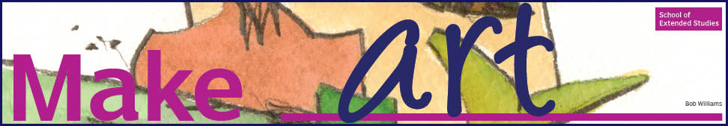

Making things is an essential part of human activity. You make your bed, you make your way to work, you make dinner. NSCAD’s School of Extended Studies encourages you to make things you didn’t think you could: make discoveries, make connections, make adventure.
The programs offered at NSCAD’s School of Extended Studies are available to the young and the young at heart, the artistic and those waiting to discover they are, the curious, and the inspired.
In every class, you make something: friends, a masterpiece,
something out of the ordinary...

The MAKE ART ROAD SHOW comes
to Halifax West Friday, February 13th at lunch in rooms B327 and B329
All are welcome :0)

ART IS...?
Ignite your inner artist! Join our community of art makers and screenprint your own poster! Or bring your own t-shirt and silkscreen that!
Don’t forget to bring your lunch!

