ART 10 OCTOBER SKETCHES
Due: Thursday, October 31st
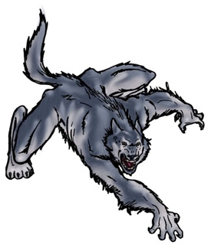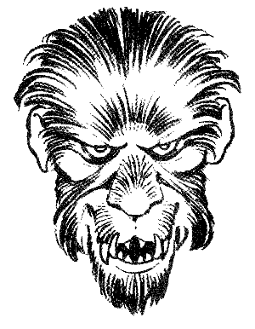
- Design a texturally stunning werewolf in time for the scaring season. Feel free to use some colour.
- Draw a large organic shape that dominates your page and within the shape create several smaller images that partially remain hidden (camouflaged).
- Design a ‘stand-out’ kite; think emphasis.

From careful observation, sit and draw a portrait of a friend or family member. Pay attention to your values.
- Sketch a live pet. Fill the page with gestural sketches.
- Invent, design and draw a robotic creature that would enhance our lives.
- Draw a city bus either from the outside or inside view.
- Free draw! Spend a minimum of one hour on this drawing…
Please remember to title and date your drawings. Include all ‘roughs’, thumbnails, written inspirations, etc.

