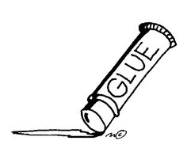
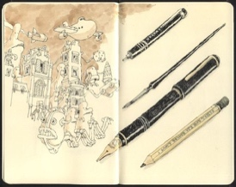
ART SUPPLIES Visual Arts 10
I.V.H.S. / R. L. Perry
DESERRES Art Supply Store
at 1546 Barrington Street (425-5566)

has available 2 super-value kits for your shopping and pocketbook ease!
They have prepared 25 option A(#72) & 20 option A+(#73) kits at great prices.
Just ask at the cash for the kit you wish to have. This is for Island View art students of Ms. Perry!

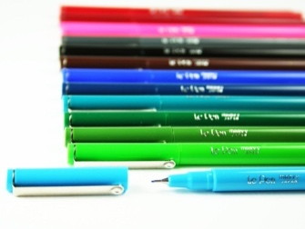
OPTION A (kit 72) $27.08 ($31.14 w/ taxes in) includes…
- 1 bound hardcover Fabriano sketchbook (8.5 x 11)/80 pages
- 1 tin of 12 drawing pencils 9B-6H
- 1 tin of 24 Faber-Castell classic coloured pencils
- 1 40 g glue stick
- 1 black ‘le pen’ fineliner 0.3mm point
- 1 white drawing eraser

OPTION A +(kit 73) $35.85 ($41.22 w/ taxes in) includes…
- 1 bound hardcover Fabriano sketchbook (8.5 x 11)/80 pages
- 1 tin of 12 drawing pencils 9B-6H
- 1 tin of 24 Faber-Castell classic coloured pencils
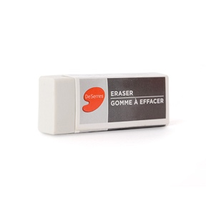
- 1 40 g glue stick
- 1 black ‘le pen’ fineliner 0.3mm point
- 1 white drawing eraser
+
- 1 tin of 12 Faber-Castell watercolour pencils w/ brush
- 1 size 0 Dynasty paintbrush
- 1 size 6 Dynasty paintbrush
