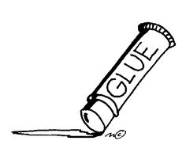
ART SUPPLIES Visual Arts 10-12
I.V.H.S. / R. L. Perry
DESERRES Art Supply Store
at 1546 Barrington Street (425-5566)

has available 3 super-value kits for your shopping and pocketbook ease!
They have prepared option A(#72) ,option A+(#73) & the NEW option B kits at great prices.
Just ask at the cash for the kit you wish to have. These are for Island View art students of Ms. Perry (Ms. Hollingshead) and Mr. Tuck.

OPTION A (kit 72) $31.99 ($ 36.79 w/ taxes in) includes…
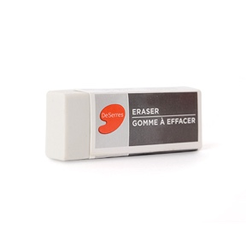
- 1 bound hardcover Fabriano sketchbook (8.5 x 11)/80 pages
- 1 tin of 12 drawing pencils 9B-6H
- 1 tin of 24 Faber-Castell classic coloured pencils
- 1 40 g glue stick
- 1 black ‘le pen’ fine liner 0.3mm point
- 1 white drawing eraser

OPTION A +(kit 73) $43.99 ($ 50.59 w/ taxes in) includes…
- 1 bound hardcover Fabriano sketchbook (8.5 x 11)/80 pages
- 1 tin of 12 drawing pencils 9B-6H
- 1 tin of 24 Faber-Castell classic coloured pencils
- 1 40 g glue stick
- 1 black ‘le pen’ fine liner 0.3mm point
- 1 white drawing eraser
+
- 1 tin of 12 Faber-Castell watercolour pencils w/ brush
- 1 size 0 Dynasty paintbrush
- 1 size 6 Dynasty paintbrush
OR
the new OPTION B a ‘bargain’ at $23.86 ($ 27.43 w/ taxes in) includes…
- 1 Accademia Sketchpad (8.5 x 11.75)/24 sheets
- 3 drawing pencils 2B, 4B & 6B
- 1 tin of DeSerres coloured pencils- 24
- 1 40 g glue stick
- 1 black ‘le pen’ fine liner 0.3mm point
- 1 drawing eraser
*If HRCE moves to phase 2, having access to the following at home would be in your favour for on-line learning with art…

A simple Prang or Reeves watercolour paint set (for colour theory and painting)
Magazines (old) for collage
Fabric scraps
Cheap wire- think Dollarama
Beads/buttons/trinkets in a junk drawer
Interesting and varied paper surfaces
Craft glue or glue gun with hot glue
Variety of tape
…you get the idea…
(don’t throw things out to purge- it might end up being your kid’s art project ;0)….)

